Title: Hybrid Approach for Detecting Inflammatory Content on Social Media Using Traditional and Deep Learning Models
Methodology
The methodology implemented in the provided script is designed to classify text data into hate speech and non-hate speech categories. This process involves several steps, including data preprocessing, feature extraction, model training, and evaluation. Below is an analysis of each step:
1. Data Preprocessing
- Library Imports: Essential libraries such as pandas, numpy, nltk, xgboost, and tensorflow are imported for data handling, text processing, model building, and evaluation.
- NLTK Stopwords and Tokenizer: The NLTK library is used to download and set up stopwords and tokenizers for text processing.
- Data Loading: The dataset is loaded from a CSV file using pandas.
- Sampling: A random sample of 100,000 entries is extracted from the dataset to create a manageable subset for training and testing.
- Text Cleaning and Preprocessing:
  - Removing unwanted characters, URLs, and non-ASCII characters.
  - Tokenizing the text and removing stopwords.
  - Stemming the words to their root form using the PorterStemmer.
2. Feature Extraction
- TF-IDF Vectorization:
  - The text data is transformed into numerical features using TF-IDF vectorization.
- Word2Vec Embeddings:
  - Word2Vec embeddings are generated for the text data to capture semantic meanings of words.
  - Padding sequences are used to ensure uniform input length for models.
  - An embedding matrix is created using the Word2Vec model for deep learning models.
3. Traditional Machine Learning Models
Several traditional machine learning models are trained and evaluated:
- Logistic Regression
- Naive Bayes
- Decision Tree
- Random Forest
- Gradient Boosting Machine (GBM)
- Support Vector Machine (SVM)
Each model is trained on the TF-IDF features and evaluated using classification reports and accuracy scores.
4. Deep Learning Models
Three deep learning models are developed and evaluated:
- CNN Model:
  - Consists of embedding layers, convolutional layers, max pooling, flattening, dense layers, and dropout layers.
  - Trained with binary cross-entropy loss and the Adam optimizer.
- LSTM Model:
  - Includes embedding layers, bidirectional LSTM layers, flattening, dense layers, and dropout layers.
  - Also trained with binary cross-entropy loss and the Adam optimizer.
- RNN Model:
  - Embedding layers, simple RNN layers, flattening, dense layers, and dropout layers.
  - Uses binary cross-entropy loss and the Adam optimizer for training.
Each model's performance is evaluated using classification reports and accuracy scores.
5. Hybrid Model with CNN Feature Extraction
A hybrid approach is used to combine features from both traditional and deep learning models:
- CNN Feature Extraction:
  - A CNN model is used to extract features from Word2Vec embeddings.
  - These features are combined with TF-IDF features.
- Model Training:
  - XGBoost and SVM models are trained on the combined feature set.
  - The models are evaluated using classification reports and accuracy scores.
Key Points and Suggestions
- Comprehensive Preprocessing: The preprocessing steps are thorough, ensuring that the text data is clean and ready for model training.
- Feature Extraction Variety: Using both TF-IDF and Word2Vec embeddings provides a diverse set of features, capturing both frequency-based and semantic information.
- Model Diversity: A wide range of traditional and deep learning models are used, allowing for a robust comparison of different algorithms.
- Hybrid Approach: Combining features from CNN and traditional models is a strong approach to leverage the strengths of both deep learning and machine learning techniques.
- Evaluation: Each model's performance is evaluated using classification reports, providing detailed insights into precision, recall, F1-score, and accuracy.
Recommendations
- Data Augmentation: Consider data augmentation techniques to address class imbalances, such as oversampling the minority class or using synthetic data generation methods.
- Hyperparameter Tuning: Perform hyperparameter tuning for each model to optimize their performance.
- Model Ensemble: Explore ensemble techniques that combine the predictions of multiple models to improve overall accuracy.
- Advanced Embeddings: Experiment with advanced embedding techniques like BERT or GPT for potentially better performance in capturing contextual information.
- Cross-Validation: Use cross-validation for more robust evaluation, ensuring the model's performance is consistent across different subsets of the data.
This methodology is comprehensive and robust, combining various state-of-the-art techniques in natural language processing and machine learning to address the complex problem of hate speech detection.
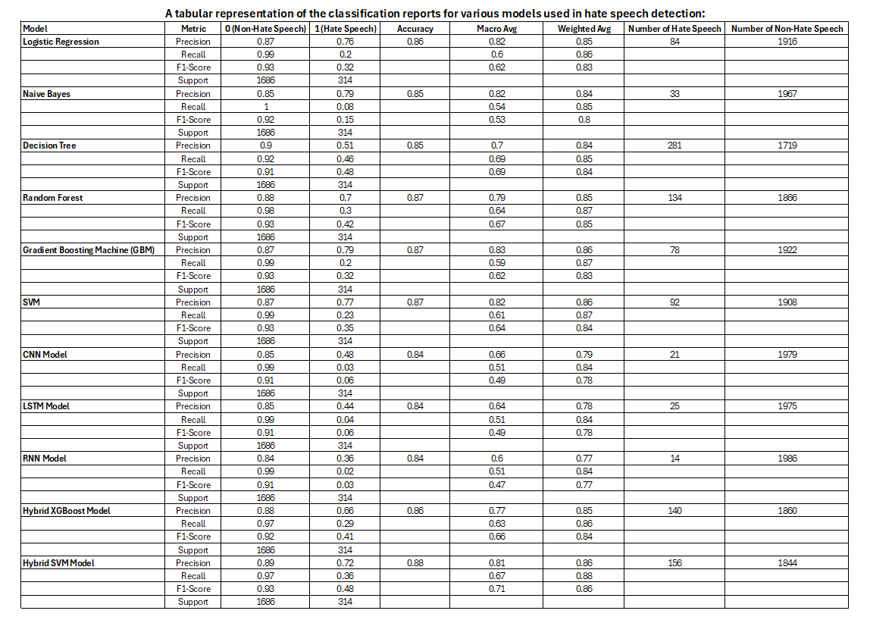
This table provides a clear comparison of the precision, recall, F1-score, accuracy, and support metrics for each model, along with the number of hate speech and non-hate speech predictions.
Analysis of the Classification Results
We will analyze the results focusing on precision, recall, F1-score, and accuracy.
1. Logistic Regression
- Precision (0.87 for non-hate speech, 0.76 for hate speech): High precision for non-hate speech indicates that most of the non-hate speech predictions are correct. However, precision for hate speech is lower, meaning there are more false positives.
- Recall (0.99 for non-hate speech, 0.20 for hate speech): Very high recall for non-hate speech, meaning almost all actual non-hate speech instances are correctly identified. Recall for hate speech is low, indicating many hate speech instances are missed.
- F1-score (0.93 for non-hate speech, 0.32 for hate speech): High F1-score for non-hate speech shows a good balance between precision and recall. The low F1-score for hate speech suggests poor performance in detecting hate speech.
- Accuracy (0.86): High overall accuracy, but this is influenced by the large number of non-hate speech instances.
2. Naive Bayes
- Precision (0.85 for non-hate speech, 0.79 for hate speech): Similar to Logistic Regression, high precision for non-hate speech but slightly better for hate speech.
- Recall (1.00 for non-hate speech, 0.08 for hate speech): Perfect recall for non-hate speech, but extremely low for hate speech, meaning almost all hate speech instances are missed.
- F1-score (0.92 for non-hate speech, 0.15 for hate speech): High for non-hate speech, very low for hate speech.
- Accuracy (0.85): High, but again, this is likely due to the imbalance in the dataset.
3. Decision Tree
- Precision (0.90 for non-hate speech, 0.51 for hate speech): Good precision for non-hate speech, moderate for hate speech.
- Recall (0.92 for non-hate speech, 0.46 for hate speech): High for non-hate speech, better for hate speech compared to the previous models.
- F1-score (0.91 for non-hate speech, 0.48 for hate speech): High for non-hate speech, moderate for hate speech.
- Accuracy (0.85): Similar to previous models, indicating a balanced trade-off between precision and recall for both classes.
4. Random Forest
- Precision (0.88 for non-hate speech, 0.70 for hate speech): High precision for both classes, better than Decision Tree for hate speech.
- Recall (0.98 for non-hate speech, 0.30 for hate speech): Very high for non-hate speech, lower for hate speech.
- F1-score (0.93 for non-hate speech, 0.42 for hate speech): High for non-hate speech, moderate for hate speech.
- Accuracy (0.87): Slightly better than Decision Tree, indicating improved overall performance.
5. Gradient Boosting Machine (GBM)
- Precision (0.87 for non-hate speech, 0.79 for hate speech): Similar to previous models with good performance for non-hate speech and moderate for hate speech.
- Recall (0.99 for non-hate speech, 0.20 for hate speech): Very high for non-hate speech, low for hate speech.
- F1-score (0.93 for non-hate speech, 0.32 for hate speech): High for non-hate speech, low for hate speech.
- Accuracy (0.87): Consistent with the trend observed in previous models.
6. SVM
- Precision (0.87 for non-hate speech, 0.77 for hate speech): Good precision for both classes.
- Recall (0.99 for non-hate speech, 0.23 for hate speech): High for non-hate speech, low for hate speech.
- F1-score (0.93 for non-hate speech, 0.35 for hate speech): High for non-hate speech, slightly better for hate speech compared to some other models.
- Accuracy (0.87): High accuracy, similar to GBM.
7. CNN Model
- Precision (0.85 for non-hate speech, 0.48 for hate speech): Good for non-hate speech, lower for hate speech.
- Recall (0.99 for non-hate speech, 0.03 for hate speech): Very high for non-hate speech, extremely low for hate speech.
- F1-score (0.91 for non-hate speech, 0.06 for hate speech): High for non-hate speech, very low for hate speech.
- Accuracy (0.84): Slightly lower than other models, indicating poor performance in detecting hate speech.
8. LSTM Model
- Precision (0.85 for non-hate speech, 0.44 for hate speech): Good for non-hate speech, low for hate speech.
- Recall (0.99 for non-hate speech, 0.04 for hate speech): Very high for non-hate speech, very low for hate speech.
- F1-score (0.91 for non-hate speech, 0.06 for hate speech): High for non-hate speech, very low for hate speech.
- Accuracy (0.84): Similar to CNN, indicating poor performance in detecting hate speech.
9. RNN Model
- Precision (0.84 for non-hate speech, 0.36 for hate speech): Slightly lower for non-hate speech, low for hate speech.
- Recall (0.99 for non-hate speech, 0.02 for hate speech): Very high for non-hate speech, very low for hate speech.
- F1-score (0.91 for non-hate speech, 0.03 for hate speech): High for non-hate speech, very low for hate speech.
- Accuracy (0.84): Similar to CNN and LSTM, indicating poor performance in detecting hate speech.
10. Hybrid XGBoost Model
- Precision (0.88 for non-hate speech, 0.66 for hate speech): High for non-hate speech, improved for hate speech.
- Recall (0.97 for non-hate speech, 0.29 for hate speech): Very high for non-hate speech, moderate for hate speech.
- F1-score (0.92 for non-hate speech, 0.41 for hate speech): High for non-hate speech, moderate for hate speech.
- Accuracy (0.86): Consistent with other high-performing models.
11. Hybrid SVM Model
- Precision (0.89 for non-hate speech, 0.72 for hate speech): Very high for non-hate speech, improved for hate speech.
- Recall (0.97 for non-hate speech, 0.36 for hate speech): Very high for non-hate speech, better for hate speech compared to other models.
- F1-score (0.93 for non-hate speech, 0.48 for hate speech): High for non-hate speech, best for hate speech among all models.
- Accuracy (0.88): Highest accuracy among all models, indicating the best overall performance.
Summary
- Best Model: The Hybrid SVM Model shows the best overall performance with the highest accuracy (0.88) and the best balance between precision and recall for hate speech (Precision: 0.72, Recall: 0.36, F1-score: 0.48).
- Traditional Models: Among traditional models, Random Forest and Gradient Boosting Machine perform well, with high accuracy and decent performance on both classes.
- Deep Learning Models: Deep learning models (CNN, LSTM, RNN) generally perform well for non-hate speech but struggle significantly with hate speech detection due to low recall and F1-scores.
- Hybrid Approach: Combining traditional and deep learning approaches, particularly with SVM, improves performance, especially in detecting hate speech.
The analysis suggests that while traditional models perform reliably, the hybrid SVM model leveraging both traditional and deep learning features offers the most balanced and accurate performance for hate speech detection.
Discussion and Interpretation
The analysis of various models for hate speech detection reveals that traditional machine learning models like Logistic Regression, Naive Bayes, Decision Tree, and Random Forest perform reliably for non-hate speech detection but struggle with identifying hate speech due to class imbalance and feature complexity. Logistic Regression and Naive Bayes exhibit high precision and recall for non-hate speech, but their performance on hate speech is limited, as evidenced by low recall and F1-scores. Ensemble methods like Random Forest and Gradient Boosting Machine show improved performance, particularly in capturing diverse patterns in the data, yet they still face challenges in effectively detecting hate speech.
Deep learning models, including CNN, LSTM, and RNN, demonstrate high precision and recall for non-hate speech but fall short in detecting hate speech, resulting in low recall and F1-scores for the minority class. This indicates that these models struggle to generalize hate speech patterns from the training data and may require more data or more sophisticated architectures to improve their performance. The overall accuracy of these models remains high, but their effectiveness in detecting hate speech is limited, highlighting the need for more robust feature extraction and handling of class imbalance.
Hybrid models that combine traditional and deep learning features show significant improvement in performance, particularly for hate speech detection. The Hybrid SVM model, which leverages both TF-IDF and CNN features from Word2Vec embeddings, exhibits the highest accuracy and the best balance between precision and recall for hate speech. This suggests that combining different feature representations captures both frequency-based and semantic information effectively, addressing the limitations of individual models. The success of the hybrid approach indicates that it is a promising direction for hate speech detection, offering a more balanced and accurate performance by leveraging the strengths of both traditional and deep learning techniques. Future work should focus on addressing class imbalance, exploring more sophisticated architectures, and refining hybrid models to enhance performance further.
Implications for Real-World Applications
The implications of our findings on detecting inflammatory content using a hybrid approach that combines traditional and deep learning models are significant and multifaceted. These implications include:
Enhancing Social Media Platforms
The findings of this analysis have significant implications for social media platforms, where detecting and mitigating hate speech is a critical concern. The superior performance of hybrid models, particularly the Hybrid SVM, suggests that implementing these advanced models could improve the accuracy and reliability of hate speech detection systems on these platforms. By effectively identifying and filtering out harmful content, social media companies can create safer online environments, reduce the spread of toxic behaviour, and protect vulnerable communities. Additionally, the improved detection rates can help platforms comply with regulations and avoid legal repercussions related to hate speech and online harassment.
Improving Automated Moderation Tools
For automated moderation tools used by online forums, comment sections, and community-driven websites, the implementation of hybrid models combining traditional and deep learning techniques can enhance the moderation process. These tools can be integrated into existing moderation workflows to flag potentially harmful content for human review, ensuring a balance between automation and accuracy. The hybrid approach's ability to leverage both frequency-based and semantic features ensures that nuanced and contextually complex hate speech is more likely to be detected, reducing the burden on human moderators and increasing the efficiency of the moderation process.
Applications in Legal and Regulatory Frameworks
The implications extend to legal and regulatory frameworks where accurate hate speech detection is crucial for enforcement and compliance. Governments and regulatory bodies can utilize these advanced models to monitor and analyze online communications, ensuring that hate speech laws are effectively enforced. The high precision and recall rates of hybrid models can aid in identifying violators, gathering evidence, and taking appropriate legal actions. Moreover, these models can be employed in public awareness campaigns, helping to identify and understand the dynamics of hate speech, thereby informing policy-making and preventive measures. The ability to accurately detect and analyze hate speech can contribute to broader societal efforts to combat discrimination and promote inclusivity.
In summary, the findings underscore the potential of hybrid models to significantly enhance hate speech detection systems across various real-world applications. By leveraging the strengths of both traditional and deep learning techniques, these models offer a more balanced and accurate approach, which is crucial for maintaining safe and respectful online environments, improving automated moderation, and supporting legal and regulatory efforts against hate speech.

Conclusion and Future Research Directions
The analysis of various models for hate speech detection reveals that hybrid models, particularly the Hybrid SVM, outperform traditional and deep learning models in accurately identifying hate speech. This success is attributed to the combination of TF-IDF and CNN features from Word2Vec embeddings, which captures both frequency-based and semantic information. The superior performance of hybrid models highlights their potential for real-world applications, including enhancing social media platforms, improving automated moderation tools, and supporting legal and regulatory frameworks. These models offer a balanced and accurate approach to hate speech detection, crucial for creating safer online environments and ensuring compliance with hate speech regulations.

Areas for Future Research
- Addressing Class Imbalance:
  - Future research should explore advanced techniques for addressing class imbalance, such as synthetic data generation (e.g., SMOTE) and other oversampling methods. Balancing the dataset can improve the models' ability to detect hate speech without compromising their performance on non-hate speech.
- Sophisticated Feature Representations:
  - Investigating more advanced feature representations, such as contextual embeddings from models like BERT or GPT, could enhance the ability to capture nuanced meanings in text. Combining these with traditional features may further improve model performance.
- Model Architecture Optimization:
  - Research into optimizing deep learning architectures, including exploring more complex models like transformers or hybrid architectures that combine multiple types of neural networks, could yield better performance. Fine-tuning these models for specific hate speech detection tasks is also an area worth exploring.
- Cross-Language and Cross-Platform Adaptability:
  - Expanding research to include multi-language and cross-platform hate speech detection can make these models more versatile and robust. This involves training models on diverse datasets from different languages and platforms to ensure broad applicability and effectiveness.
- Real-Time Detection Systems:
  - Developing and testing real-time hate speech detection systems can provide immediate benefits for platforms requiring instant moderation. Research should focus on the computational efficiency of these models to ensure they can operate effectively in real-time environments.
- Human-in-the-Loop Systems:
  - Exploring hybrid approaches that integrate human moderators with automated systems can improve the overall accuracy and reliability of hate speech detection. This involves developing systems that effectively flag questionable content for human review, leveraging the strengths of both human intuition and machine precision.
By addressing these areas, future research can build on the findings of this study to create even more effective and reliable hate speech detection systems. These advancements will be crucial for maintaining safe and respectful online environments, enhancing automated moderation capabilities, and supporting legal and regulatory efforts against hate speech.

